CAKE AND COOKIES WITH THE CHIEF
Please join us on February 13th, 2023, for cake and conversation, to welcome The Town of Kenly’s new Police Chief, James Ayers.
Location: 207 W Second Street, Kenly, NC Council Chambers
Time: 5:30pm to 6:30pm.
For more information, please contact The Town Hall at 919-284-2116.

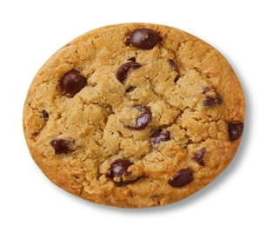

CAKE AND COOKIES WITH THE CHIEF
Please join us on February 13th, 2023, for cake and conversation, to welcome The Town of Kenly’s new Police Chief, James Ayers.
Location: 207 W Second Street, Kenly, NC Council Chambers
Time: 5:30pm to 6:30pm.
For more information, please contact The Town Hall at 919-284-2116.

CAKE AND COOKIES WITH THE CHIEF
Please join us on February 13th, 2023, for cake and conversation, to welcome The Town of Kenly’s new Police Chief, James Ayers.
Location: 207 W Second Street, Kenly, NC Council Chambers
Time: 5:30pm to 6:30pm.
For more information, please contact The Town Hall at 919-284-2116.

